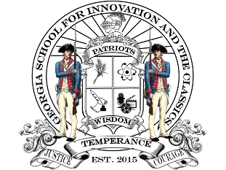

**Hephzibah Charter Foundation**

***(Georgia School for Innovation and the Classics)***

***Meeting Agenda for October 18, 2022***

**CALL TO ORDER**

1. **Administrative Functions** 
   * Approval of Agenda
   * Approval of Minutes
2. **School Related Reports**
   * School Report
3. **Financial Reports**
   * Monthly Financial Reports
4. **Old Business**
   * Discussion to improve dismissal car line.
5. **New Business**
   * “Public Conduct” and “Unstructured Break” Policies presented for Board approval.
   * Mr. Wren (GSIC Parent) concerned with dress code item. (Facial hair for students)
6. **Next Meeting Date**
   * November 15, 2022

**ADJOURNMENT**